Assignment 2 - Detailing A Game Environment

**[Elemental Shard]**

[Student Name:Zhaomin Liu]

[Student ID:32229763]

# 

**Mechanics Design 2**

Gameplay Genre 2

Game Goals 2

Game Challenges/Goal: 2

Level Challenges/Goal: 2

Sub-Level Challenges/Goal: 2

Atomic Challenges/Goal: 2

Level 1 Sub-Level goal 5 Atomic Goal: 1.Shoot the crystals by right sequence to unlock the gate. 3

Game Mechanics 3

Space 3

Time 3

Objects, Attributes & States 4

Actions 5

Rules 5

Skills 5

Chance 6

**Level Design 7**

Level Design 1 7

Drawing of Level 7

Level Description 7

Mechanics Present 8

Drawing of Level 9

Level Description 9

Mechanics Present 10

**Critical Analysis 11**

Challenges and Player Skill: 11

Balancing: 11

Level Layouts: 12

Difficulty and ‘Flow’: 12

Genre Conventions: 12

# 

# Mechanics Design

## 

## Gameplay Genre

My game is a fps game with puzzles in a future world.Players not only need to fight with enemies,but also have to go through jumping puzzles and shooting puzzles by future style tools.

## Game Goals

### Game Challenges/Goal:

Player’s final goal is finding the elemental shard and recovering the past memory.

### Level Challenges/Goal:

Level 1: Defeat the “doctor” and unlock the map.

Level 2: Defeat the “elemental ghost” and get the elemental shard.

### Sub-Level Challenges/Goal:

Level 1 Sub-Level Goal 1: Find a way out from the lab

Level 1 Sub-Level Goal 2: Leave the building

Level 1 Sub-Level Goal 3: Kill the high-level guard

Level 1 Sub-Level Goal 4: Reach the crypt

Level 1 Sub-Level Goal 5: Enter the crypt

Level 1 Sub-Level Goal 6: Kill the “doctor”

Level 1 Sub-Level Goal 7: Use “doctor”’s map to locate the elemental shard.

Level 2 Sub-Level Goal 1: Reach the spaceship

Level 2 Sub-Level Goal 2: turn off the security system

Level 2 Sub-Level Goal 3: Kill the corrupted beast

Level 2 Sub-Level Goal 4: Unlock the corrupted gate

Level 2 Sub-Level Goal 5: Kill the “elemental ghost”

Level 2 Sub-Level Goal 6: Get the elemental shard before the explosion

### Atomic Challenges/Goal:

Level 1 Sub-Level goal 1 Atomic Goal: 1.Jump through the rift

2.Climb the wall to reach the top door 3.unlock the door by knife

Level 1 Sub-Level goal 2 Atomic Goal: 1.Kill the guard

2.Collect the key card

3.insert the key card and shoot the right symbol

Level 1 Sub-Level goal 3 Atomic Goal: 1.Shoot to break the recovery modular

2.Shoot the bomb to make high-level guard dizzy

3.Kill the high-level guard

Level 1 Sub-Level goal 4 Atomic Goal: 1.Jump through the rift by platforms

2.Kill all enemies near the rift to discover the crypt

## Level 1 Sub-Level goal 5 Atomic Goal: 1.Shoot the crystals by right sequence to unlock the gate.

Level 1 Sub-Level goal 6 Atomic Goal: 1.Shoot down the battery to turn off the shield

2.Use the battery to cancel the self destruction

3.Shoot the “doctor” to kill him

Level 1 Sub-Level goal 7 Atomic Goal: 1.Search the crypt to find the password

2.Access the map

Level 2 Sub-Level goal 1 Atomic Goal: 1.Turn on the power

2.Use the elevator to reach the spaceship

Level 2 Sub-Level goal 2 Atomic Goal: 1.Kill corrupted guard to get key card

2.Access the security room and turn off the system

Level 2 Sub-Level goal 3 Atomic Goal: 1.Pick up the flash bomb to make the beast blind temporarily

2.Shoot the corrupted beast to kill it

Level 2 Sub-Level goal 4 Atomic Goal: 1.Insert the bomb

2.Kill corrupted enemies,survive until the explosion

3.Insert the heart of corrupted beast to unlock the gate

Level 2 Sub-Level goal 5 Atomic Goal: 1.Shoot the symbols by right sequence

2.Kill the servant of ghost

3.Pick up the heart of servant to get a shield

4.Step into the flame to get blade

5.Use the blade to destroy the elemental ghost

Level 2 Sub-Level goal 6 Atomic Goal: 1.Jump to the top of spaceship and collect the elemental shard

## Game Mechanics

My game is a sci-fi,3d fps game but many elements are very close to the real world.Time and space may limit the player,but they can also use that to gain advantage.Player can also use many objects.

### Space

My game is a 3D fps game with a lot of small spaces.My spaces is continuous and areas in all levels are connected in one world.Player can move to any direction by walk,run or jump.Player is able to turn back to last area to collect secret loots or information if they want.

### Time

Time in my game is continuous.Enemies will walk around even player stops,and the day night cycle will work as normal.Player will feel more difficult during the night,because the daylight will make the corrupted enemies weaker.Boss encounters will include the time-based challenges,Player must finish the challenges before countdown.

### 

### Objects, Attributes & States

Objects: 1.Player

2.normal guard

3.High-level guard

4.”Doctor”(boss)

5.corrupted guard

6.corrupted beast(boss)

7.elemental ghost(boss)

8.servant of ghost

Attributes: 1. Player health

1. Player’s Armor
2. Pistol (medium damage,low fire rate with low mag capacity)
3. Knife (high damage melee weapon,good tool)
4. Assault Rifle (low damage,medium fire rate with high mag capacity)
5. Shotgun (high damage,low fire rate with low mag capacity)
6. Arc Rifle (medium damage,high fire rate with low mag capacity)
7. Health packet
8. Grenade
9. Audio cassette (player can listen it to get tips or secret)
10. Message pad (player can look it to get level information)
11. Normal guard health
12. High-level guard’s recovery modular
13. High-level guard health
14. “Doctor” armor
15. “Doctor” health
16. Corrupted guard health
17. corrupted beast armor
18. Corrupted beast health
19. Servant of ghost shield
20. Servant of ghost health
21. Elemental ghost shield
22. Elemental ghost health

States: 1. Player have armor and health.Player will be damaged after the armor is broken.

1. Normal guards have low health and no armor.They can do very low damage by rifles.Normal guards have no special ability.
2. High-level guards have high health and the ability to recover.But the damage of high-level guard’s guns is not very high,players have many chances to try.
3. “Doctor” is the first boss with low health but high armor.It can use arc energy to attack players,arc energy has very high damage.”Doctor” has an untouchable shield and it is able to activate the self-destruction process.
4. Corrupted guards have higher health but low damage same as normal guard.Corrupted guard can call fellows to join the fight.
5. Corrupted beast have high armor and low health with high damage.It can move very fast and break the player’s armor by one attack.
6. Elemental ghost is the final boss of my game,it cannot be damaged by guns.Elemental ghost can call all corrupted enemies to join the fight,and attack the player by fire or poison.The damage of elemental ghost is very high.
7. Servant of ghost have medium damage and a strong shield.It can do medium damage by fire.

### Actions

1. Player can move to any direction and jump to higher place
2. The player can use guns to shoot enemies or use melee weapons to attack them.
3. The player can shoot the symbols to solve puzzles.
4. The player can pick up the message or loot.
5. Player’s first ability is extra armor,which can give the player extra armor but very low mobility temporarily.
6. Player’s second ability is weaken bomb.This bomb will do damage to enemies and make them weaker.Player can do more damage to them.
7. Players can sneak through all normal enemies to avoid unnecessary fights,this strategy allows the player to reach the boss encounters very fast.But they may lack the necessary resources by this way.

### Rules

1. Players can move anywhere inside my game world.
2. Player will die if his/her health equals 0.
3. Player must not be in a fight when he/she wants to enter the next area.
4. Players will die if they fail to finish the boss encounter goal for 4 times.
5. Players will restart at the last checkpoint if they die in boss encounters.
6. For some goals,players have to restart at the last checkpoint if he/she failed to finish before countdown=0.
7. Player’s ammo inventory has maximum value,he/she has to control the resource in my game.
8. Players can find the recovery packet in some areas,he/she can have a maximum 3 recovery packets in inventory.

### Skills

1. Mental skills: Puzzle solving/Understanding skill is very important in my game,many goals ask player to solve the puzzles.For example,the player needs to finish the shoot the symbols by sequence to leave the building in level 1.He/she needs to understand how to do that.
2. Physical skills: In the highest difficulty setting,player should have a fast reaction rate.For example,the corrupted beast can kill the player in 2 attacks in higher difficulty setting.Player needs to have fast reaction to avoid the attacks.
3. Social skills: My game is a solo-player fps game,no social skills needed.

### Chance

1. Normal guards have a certain patrol route,the player can check it and avoid them.Player’s skill can increase the chance of success.
2. Messages are put on the map randomly,this is the randomness in my game.Player can dictate messages by chance.
3. Secret loot is put on the map randomly.If player collects enough messages,he/she can find the loot easily.But they can also just dictate loot by chance.
4. AI of Bosses increases the randomness,bosses may select the way to attack the player randomly.Player can increase the chance of successful dodge by experience.

# Level Design

## Level Design 1

### Drawing of Level

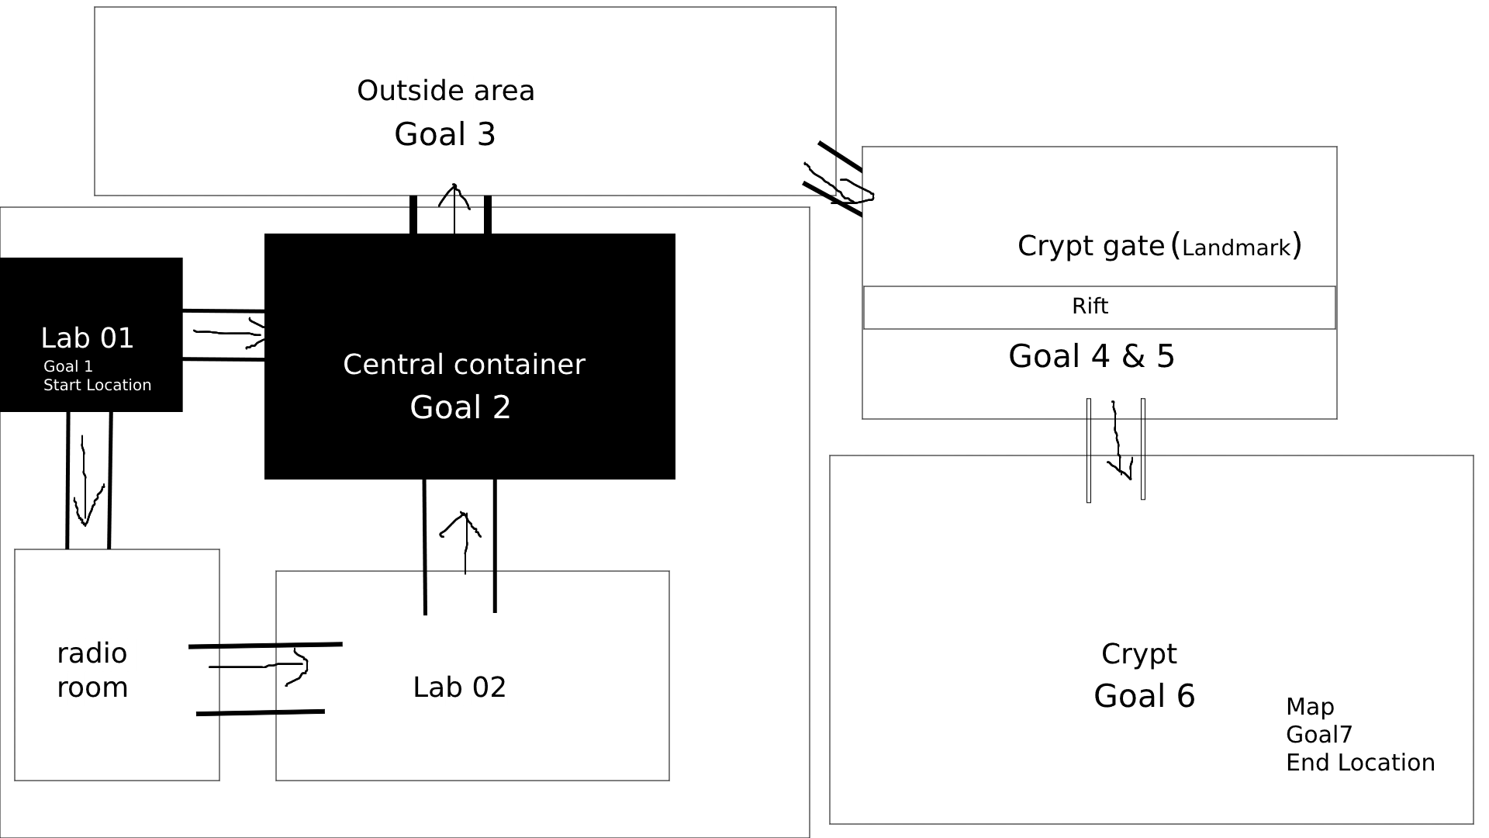

### Level Description

Level 1 of my game is a combination level.Player will wake up at Lab 01 and jump through rift and climb up to reach the door.Or player can turn right to find a small door lead to radio room and go through Lab 02 to reach the central container.This route requires no jump skill but player will face more enemies.

And player can find more information on this route.

Central container is the exit location of this build.Player needs to kill all guards in this place and find the key card.Then player can insert the key card and shoot symbols to finish a puzzle to open the exit door.I will give no tips for this puzzle,but the light of symbols will show player what he/she needs to do.

High-level guard will attack the player once he/she steps into the outside area.Player must kill the high-level guard to continue,he/she cannot sneak through to avoid this fight.

Crypt gate is the landmark of level 1.This huge gate will remind player that he/she is on the right track.Player needs to jump through the rift by jumping and shooting the right switches to solve a puzzle.Then player has to kill all enemies near the rift to continue.

Once the player steps into crypt,”Doctor” encounter will be started.Player must kill him to continue.But player won’t find the password on “Doctor”’s body,he/she has to check around the crypt to find the password and access the map.

### Mechanics Present

At the start location:Lab 01,player needs to jump through a rift and climb to the top.This part will test there movement skills.If player doesn’t want to do so,he/she needs to go through 2 more rooms before central container.Which means more enemies,player will feel difficult to fight or sneak through.Player can find a recording about this building in radio room.In Lab 02,player can find some ammo and a recover packet.Normal guard in Lab 02 will drop the assault rifle,player can pick up and use it.Under higher difficulty setting,player can find less ammo and no recover packet in lab 02.

In central container room,player needs to kill all guards in this place and find the key card from their bodies.Then player needs to insert the key card,and he/she can see 3 symbols show up with a sequence.Player should shoot 3 symbols by that sequence to enter the next stage of puzzle.Second stage of puzzle requires player to should down all symbols they can see to finish.Once this puzzle is finished,exit door will be opened and player can get a shotgun as reward.Under high difficulty setting,player will fight more stranger enemies and shoot 5 symbols by sequence.

In outside area,player will face the high-level guard.High-level guard have very high health and a recovery modular.Player has to break the recovery modular at first.Otherwise,it is impossible to kill high-level guard.Without recovery modular,high-level guard still have very high health and high mobility.Player needs to shoot the bomb in area to make it dizzy.If high-level guard is dizzy,it will be fragile and easy to kill.

High-level guard will drop the arc rifle after its death.Under higher difficulty setting,player has to break 2 recovery modular on high-level guard’s chest and back before making it dizzy.

In crypt gate area,player will go through a huge rift between him/her and crypt gate.Player needs to finish a jumping puzzle.At first,player can go through some platforms easily and reach a big platform as first checkpoint.Player will restart at this checkpoint if he/she dies before next checkpoint.Second stage requires player to jump through a lot of moving platforms and shoot the right switch to get a bridge.Right switch have green light,player can find it easily.Player will fall down and die if he/she shoot the wrong switch.The bridge will lead player to second checkpoint.Third stage of the jumping puzzle requires player to go through a big platform with many blocks.Player has to go through blocks by right sequence,sequence will be shown at the ground of second checkpoint.After this platform,player needs to kill all enemies near the rift to dispel the fog.Then the crypt gate will be shown.Under higher difficulty setting,the enemies near rift will include one high-level guard.

There are 7 crystals on the crypt gate.Crystals will be lightened with a sequence.Player needs to shoot the crystal by that sequence to open the gate.

Player will be attacked by “Doctor” once he/she steps into the crypt.”Doctor” have a shield to prevent damage.Player must shoot down the battery near the shield to turn it off.If the shield is turned off,”Doctor” will start a self-destruction process.Player needs to pick up the battery and put it into the control system in 30s to stop the self-destruction process.”Doctor” will keep attacking player at the same time.After the self-destruction is stopped,”Doctor” will become fragile and player needs to kill him in 60s.Under higher difficulty setting,player needs to shoot down 2 batteries to turn off the shield.But stopping the self-destruction process still need just one battery.What’s more,”Doctor” will have higher armor and health.

Then the player needs to check the crypt and find the password under a loot chest.Then player can access the map and locate the elemental shard.

**Level Design 2**

### Drawing of Level

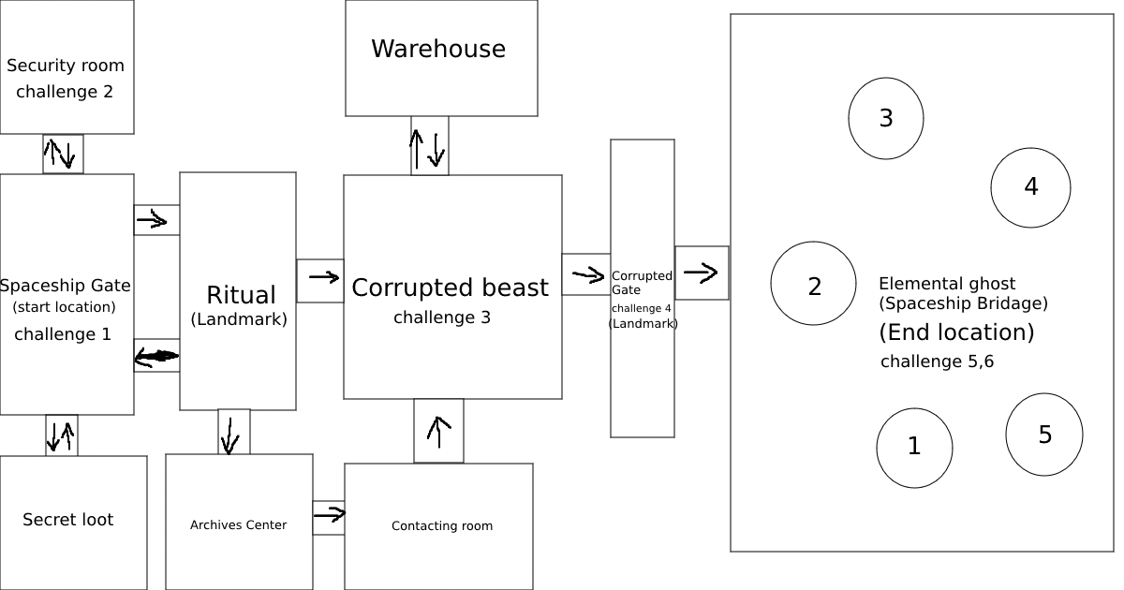

### Level Description

Level 2 of my game is a network level.At the beginning of this level,player needs to turn on the power and use the elevator to reach the spaceship gate.

Then Player will face the corrupted guard.Player must kill all corrupted guards near the spaceship gate to get the key card of the security room.Then player needs to enter the security room and turn off the security system by an easy puzzle.

After the security system is turned off,player can go back to the gate and continue this level.Player can choose 2 way.One of the way will lead player to a secret loot.Player can find a recover packet,2 grenades and ammo supply in this room.Another way lead player to ritual room.This is a landmark of this level.The stone tablet in ritual room is very huge,player will know that he/she is approaching a power enemy.There are many corrupted guards near the ritual.

Player can choose 2 ways to continue,one way lead player to corrupted beast boss encounter directly.Another way lead player to archives center,contacting room and then reach the corrupted room.Archives center have no enemy,player can collect audio cassette and message here and then enter the contacting room.Player will find some corrupted guards here but not much,he/she can find extra ammo supply and a recover packet in contacting room.

Then player will face the corrupted beast.Once player step into the boss encounter area,he/she cannot leave until the boss is defeated.Player has to make the corrupted beast blind before attacking it.It has low health and high armor.Player will see the corrupted gate.

Player needs to insert a bomb on corrupted gate at first.Then a lot of corrupted guard will come to player and try to kill him/her/.Player must survive through this and then insert the heart of corrupted beast to open the gate.

Elemental ghost will fight with player in spaceship bridge.Player must read the sequence of symbols and shoot that.Then elemental ghost will call its servant.Player needs to kill the servant and pick up the heart to get a shield.Servant will have a shield,which can remind player to use it.At the same time,a fire platform with a blade will come up.Player needs to use the blade to kill elemental ghost.

After the elemental ghost dies, a door to the top of the spaceship will be opened and the player needs to jump to that door to collect the elemental shard.

### Mechanics Present

At the beginning,the player needs to walk through a path and find the power.Then player can turn it on to use the elevator.

Near the spaceship gate,the player needs to kill all corrupted guards quickly.Because they have ability to call fellows.If player cannot finish the fight quickly,the enemies will become more and more.

In the security room,the player will go through a small puzzle.Player needs to click the blocks by sequence to finish it.Then the security system will be turned off.There are many corrupted guards near the ritual stone tablet,but the player can choose to sneak through.

In corrupted beast boss encounter,player must kill corrupted guards to get flash bomb to blind the corrupted beast.Each flash bomb can make the corrupted beast blind for 10s.Player must kill the beast by maximum 4 bombs.Otherwise,player will die and restart this encounter.

Near the corrupted gate,player needs to get a bomb by kill corrupted guard.This bomb will give an explosion after 90s.A lot of enemies will come up and try to kill player.Player must kill them to survive.After the explosion,player can insert the heart of corrupted beast into the gate to open it.

At the beginning of the elemental ghost encounter,player needs to read 5 symbols by sequence and shoot that.After all symbols are broken,elemental ghost will summon its servant.This servant have a strong shield but low health,player needs to kill it quickly and pick up the heart to get shield.If player just step into the fire to take blade without shield,player will die immediately.Player cannot do damage to elemental ghost by guns,only the blade can kill the elemental ghost.Elemental ghost will use crystal to break the blade,then player has to pick up another one to continue until the elemental ghost die.

To pick the elemental shard, the player must reach the door in the 60s.Otherwise,the shard will be broken and the player has to restart.

# Critical Analysis

## Challenges and Player Skill:

My game is a sci-fi fps game with puzzles.So I include the shooting puzzle,jumping puzzle and boss encounters in challenges.

For goal 1 and goal 2 in level1,player just need to jump and climb for a little and kill some normal guards to finish.The puzzle challenge to leave building is also easy.This part will test the reaction and puzzle solving skills,but just a little.

Goal 3 in level 1 will be difficult to player at first,it ask player to understand the mechanics of high-level guard.Player needs to break the recovery modular, make it dizzy then kill it.This challenge will test the player’s reaction skill and understanding skill.Sun will go down at this time.

Goal 4 in level 1 is a difficult jumping puzzle,player needs to understand all mechanics to pass.This jumping puzzle will test player’s puzzle solving skill and reaction skill.A sound of reminder will be given as feedback at the end.

Goal 5 in level 1 is a very easy puzzle,which can give player a breath before facing the “Doctor”.

Goal 6 in level 1 asks the player to kill “Doctor” by turning off the shield,stopping self-destruction and do damage.It is a difficult and time-limited encounter,player should have good reaction skill to pass it.

Goal 7 in level 1 is also easy,player just need to find the password and access the map.It is a relaxing after boss encounter.

Goal 1 in level 2 is a easy one,player just need to turn on the power and use the elevator.I don’t want to give a difficult challenge at the beginning.

Goal 2 in level 2 is also easy,player just need to kill corrupted guards and use the key card to turn off the security system.An alarm will be shown after player turned the security system off as a feedback.

Goal 3 in level 2 is a difficult one,player needs to make the corrupted beast blind at right time to kill it.This challenge will test player’s reaction skill.The heart of corrupted beast will be shown as feedback after the challenge is finished.

Goal 4 in level 2 is a medium one,this one doesn’t have difficult mechanic.But player has to kill many enemies to survive.A light as feedback will be shown when player can insert the heart of corrupted beast.

Goal 5 in level 2 is the most difficult one.Player needs to read the symbols,kill servant,pick up shield,take the blade and then kill the elemental ghost.It will test player’s reaction and understanding skills.Elemental ghost will vanish as feedback at the end of this challenge.

Goal 6 is no that difficult,but player must be quick to jump to the top.It is will test player’s reaction skills.

## Balancing:

I found the sneaky strategy was dominant,player can avoid many combats and just fight with bosses.So I adjusted the resource of my game.Player has only a little resource at the beginning,and secret loots can just give a little resource.Player has to kill enemies to get enough resource to continue.But I still keep the sneaky strategy for players who are very familiar with this game.This strategy still exist but not a easy way,I believe this is better than just delete the sneaky strategy.

Arc rifle also very powerful,it has much higher DPS than any other weapons.So I gave a low mag capacity rather than nerf the damage.Which means that arc rifle won’t lose the specialty,but player has to reload frequently and often lack the arc rifle ammo.Then player will choose other weapons for many challenges rather than just use arc rifle.It is bad to nerf the damage or fire rate directly to kill a weapon,the best way is nerf some values but keep the specialty.And give other weapons more chances.

Weaken is a powerful ability.To avoid the dominant strategy,bosses in my game are immune to this bomb.Player can still use it to kill high-level guard ,corrupted guards or normal guards.

## Level Layouts:

My level 1 is combination layout level.It is a combination of linear and network layout.I believe that network and linear layout should be better than just linear layout.My layout allow player to explore more than just go through the goals.Player can choose their own path to continue. Landmark of level 1 is the crypt gate.It is a very huge gate,player can find it easily and know the right direction immediately.Player can see a part of crypt gate when he/she step in to the outside area.After they finish the goal 4 in level 1 and dispel the fog,the whole gate will be shown.

My level 2 is a network layout level.Player can choose their own path and turn back to collect loots at any time.This is a good choice because my level 2 is more difficult and gives player heavy pressure.Network layout allow them to explore and take a breath between challenges. Landmark is the stone tablet in ritual area,this tablet is huge and shining with red light.Player will know the right direction and realize he/she is approaching a power boss.

## Difficulty and ‘Flow’:

Absolute difficulty:

At the beginning of level 1,player can finish the challenge 1 and 2 easily.Because player just start to learn how to move and fight in my game.But Goal 3 challenge will increase the absolute difficulty of my game.Player will face a new enemy called high-level guard, they may feel confused about this enemy at first.Player has to learn and try to defeat the high-level guard.But player will feel easy after understand the mechanic of high-level guard,which keep players within the flow zone.

Level 1 goal 4 requires player to go through a long,difficult jumping puzzle.Player will feel difficult at first but much easier after he/she find the right mechanic.

After the “Doctor”,my game’s absolute difficulty will be higher and higher due to the new corrupted enemies.Which requires player with better skills.For the last boss elemental ghost,it has most difficult mechanic and highest strength.

Relative difficulty:

Player will feel difficult to fight with bosses if they have no enough resource like ammo or recover packet.With enough resource,mistakes are acceptable for player.They can have more chances to defeat the bosses.

Perceived difficulty:

Players will feel confused to puzzles and boss mechanics in my game if they are new players.And when I increase the absolute difficulty at goal 3 level 1,player haven’t learn too much from my game.I believe this is a good setting.

## Genre Conventions:

I included many future weapons and devices in my game to fit my future genre.For example, arc rifle is not exist now but people may invent it in the future.Corrupted enemies also as a part of conventions,such kind of ideas are usually shown in many movies and games.

In many fps games,designer will give players shooting or jumping puzzles to make the game interesting.If a games just have fight,it will be boring.I did the same thing.Jumping and shooting puzzles can also test more skills of players.

I also offered different weapons for players.Most fps games will allow players to choose different weapons to deal with different enemies.Different weapons can give players different experience.

What’s more, I added mechanics to all boss encounters.Many games did that.If the bosses in a game just have more health and higher damage,that is too boring and cannot be called as bosses.Different mechanics related to different bosses.

I offered different routes and unnecessary rooms for player to explore,which is usual in many games to make the content richer.